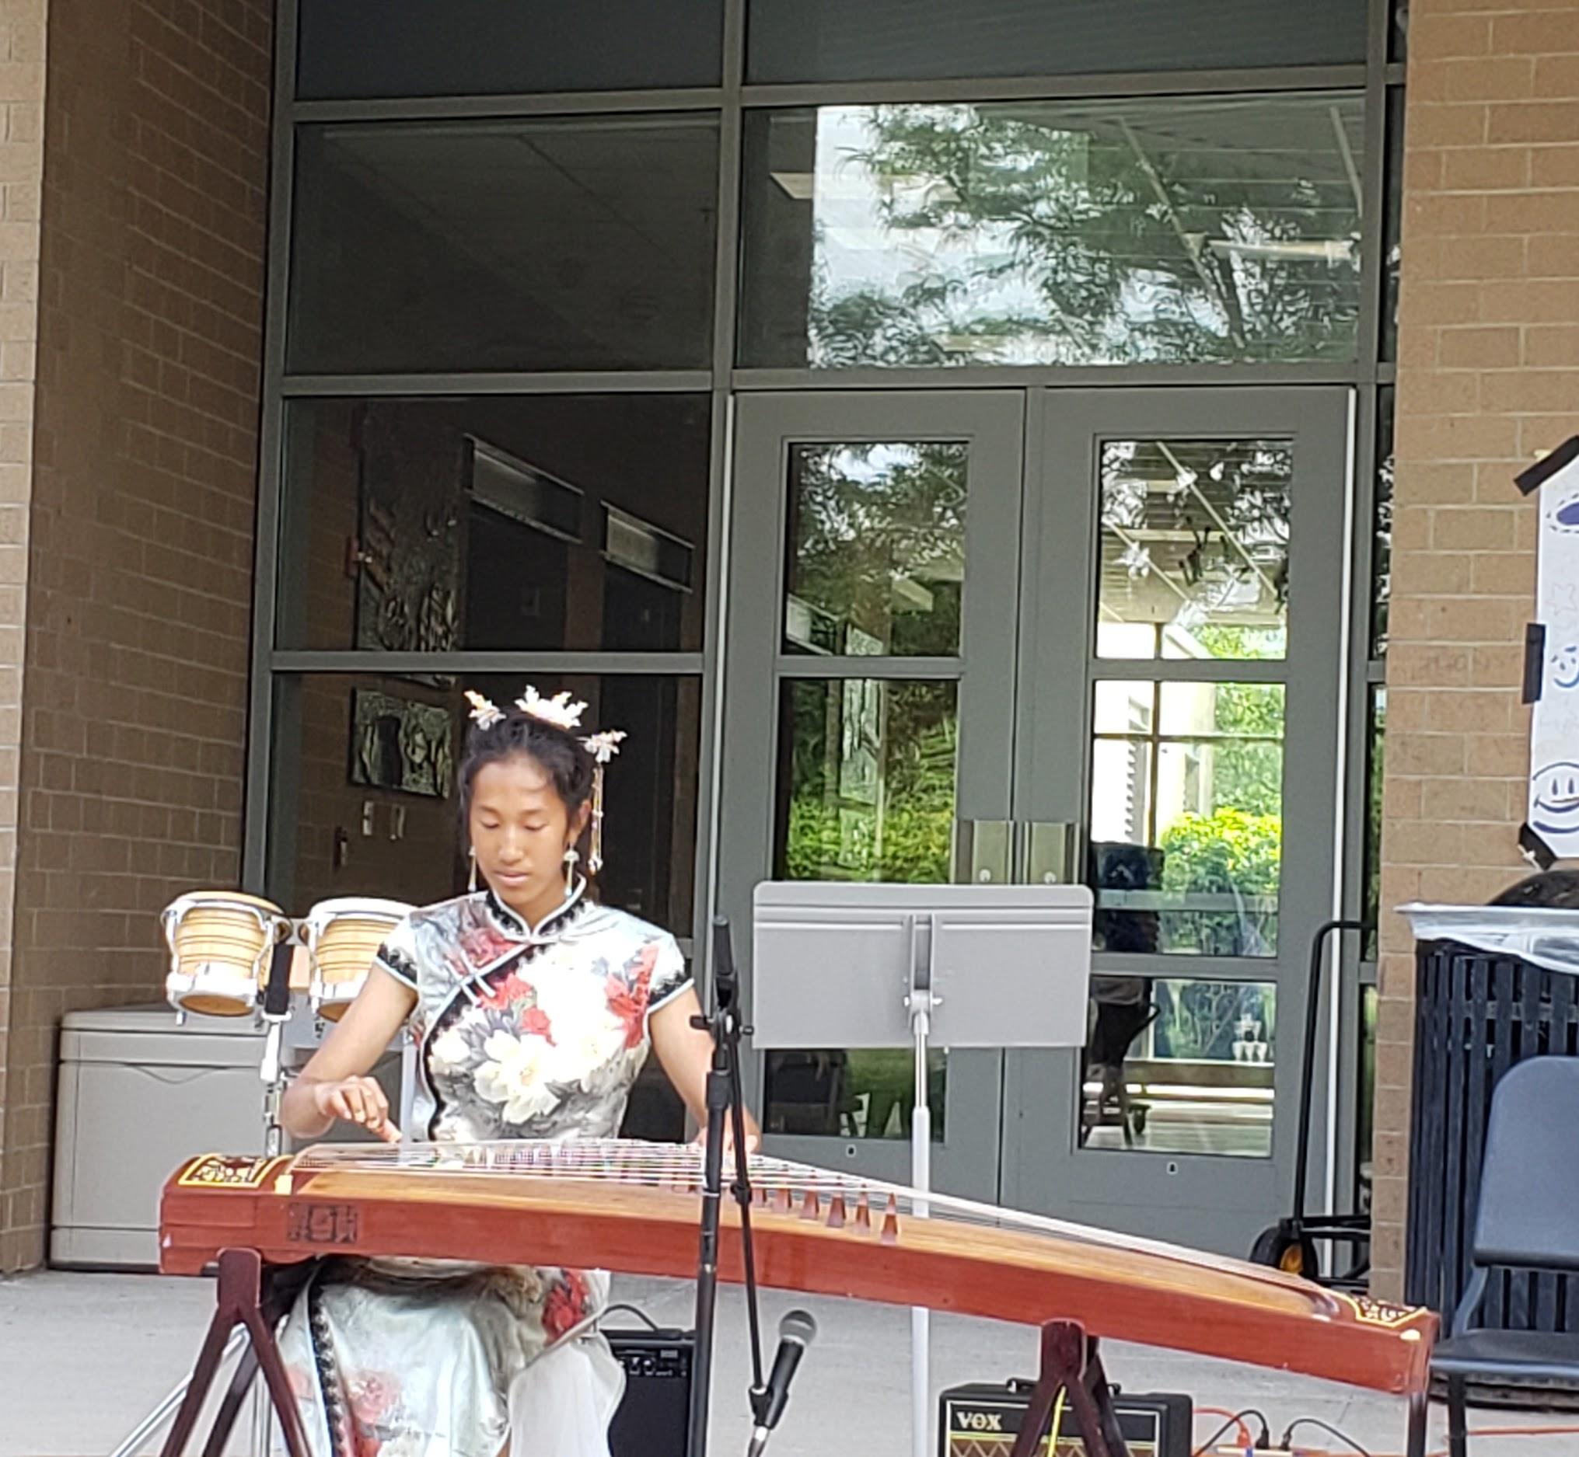
July/August Recap
On Friday, July 15, Sophia, Max, and Jasmine represented SoWE, performing at Navy Pier’s 2022 Fresh Fest.
Thank you to all those who made this year’s July 23rd annual meeting a success! Congratulations to all our performers and award recipients! It was incredible seeing everyone!

Upcoming Events
Last year, SoWE’s musical performance team attended the Navy Pier Fresh Fest. The Chinese Fine Arts Society has once again invited SoWE to this year’s performance, on July 14-15.
On Saturday, July 23, SoWE will have our annual meeting at the Chinese Community Center (250 W 22nd Pl, Chicago, IL 60616) in the afternoon. The tentative time is 1:00- 4:00 pm. The board will finalize a time and update everyone through our WeChat group. Our current outline is as follows:
- Board Introductions
- Performances (with a short intermission)
- Awards Ceremony
- College Student/Alumni Speeches (refreshments will be served)
Recent and Upcoming Videos
Mika’s solo, Ghost was uploaded to the SoWE Youtube channel.
Angela’s solo, Speak Softly Love (The Godfather Theme) has also been posted.
Feel free to check out these videos and please be on the lookout for upcoming posts!
Notices
Reminder to SoWE volunteers: Please finalize and submit your 05/01/2021-04/30/2022 volunteer hour logs. We will reward volunteers with certificates for their number of logged hours throughout the fiscal year at our annual meeting. Please remember to continuously update your logs throughout the year, whenever you have earned hours.
Reminder to all annual meeting performers (including students): Please fill out the entire Google Form, particularly the song name/description and estimated time if you plan on performing during this year’s annual meeting.

