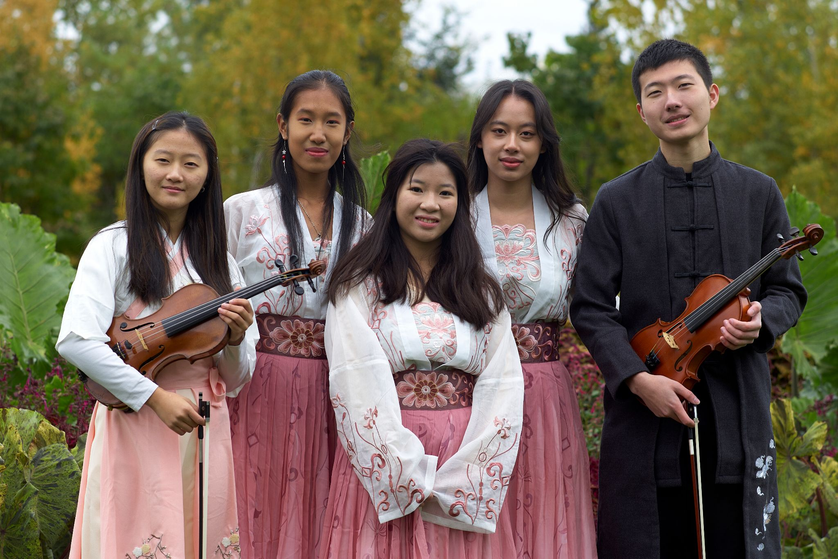
October/November Recap
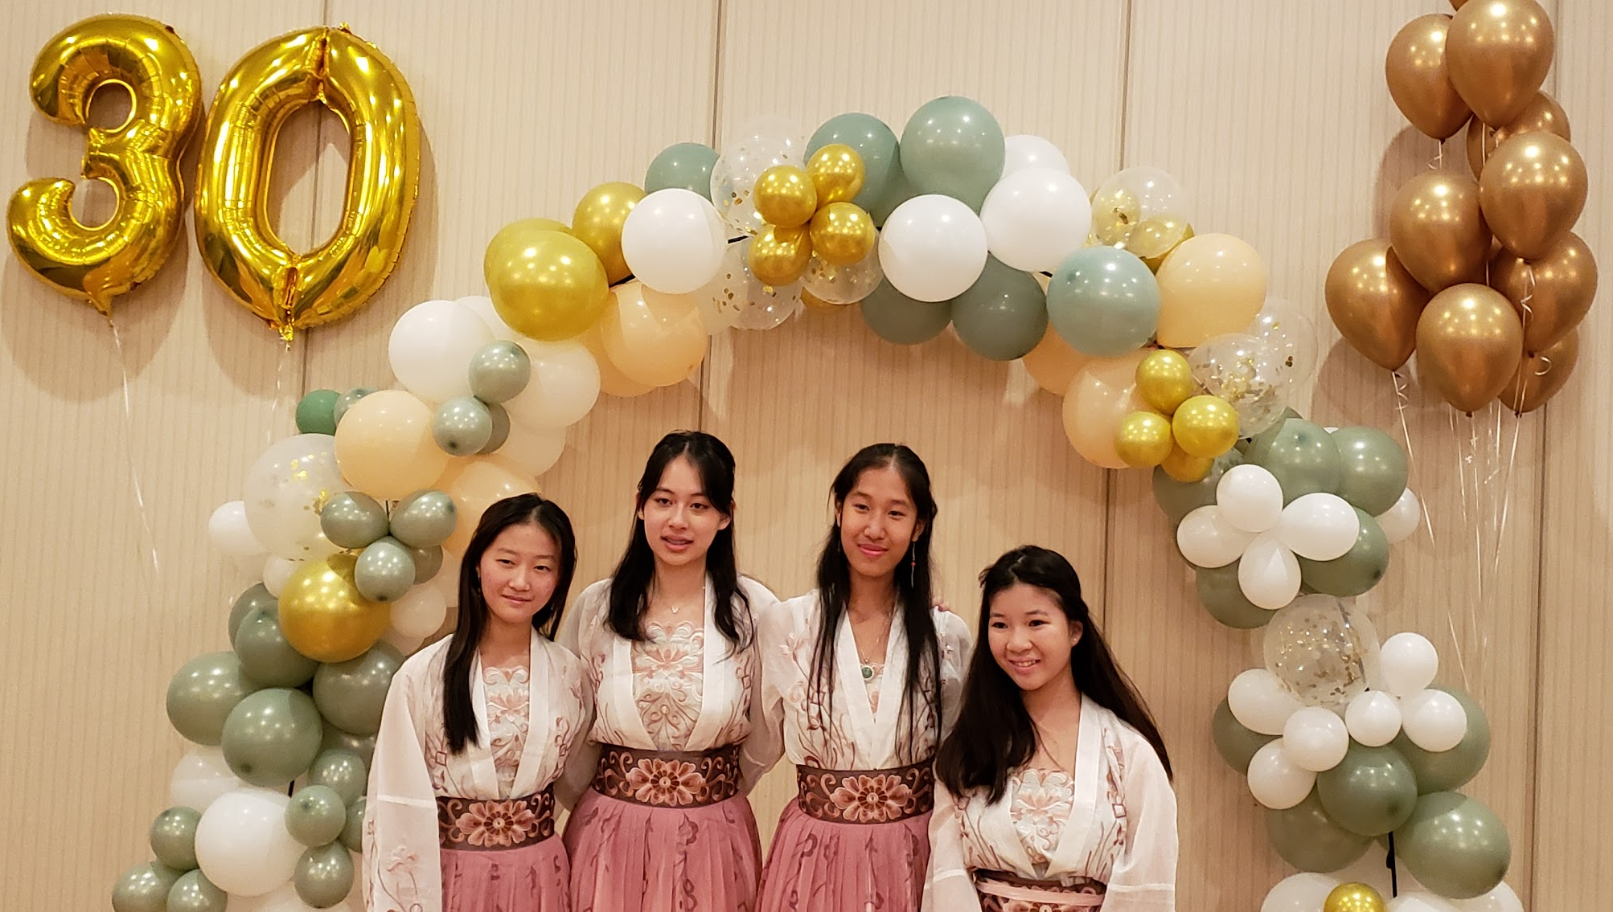
On Sunday, October 16, SoWE participated in the annual Walk for Wishes at Lincoln Park Zoo. SoWE exceeded our goal, raising a total of $2,642! We really appreciate all those who donated and attended the walk.
SoWE performed at Ray Chinese School’s 30th anniversary celebration on Friday, October 21.
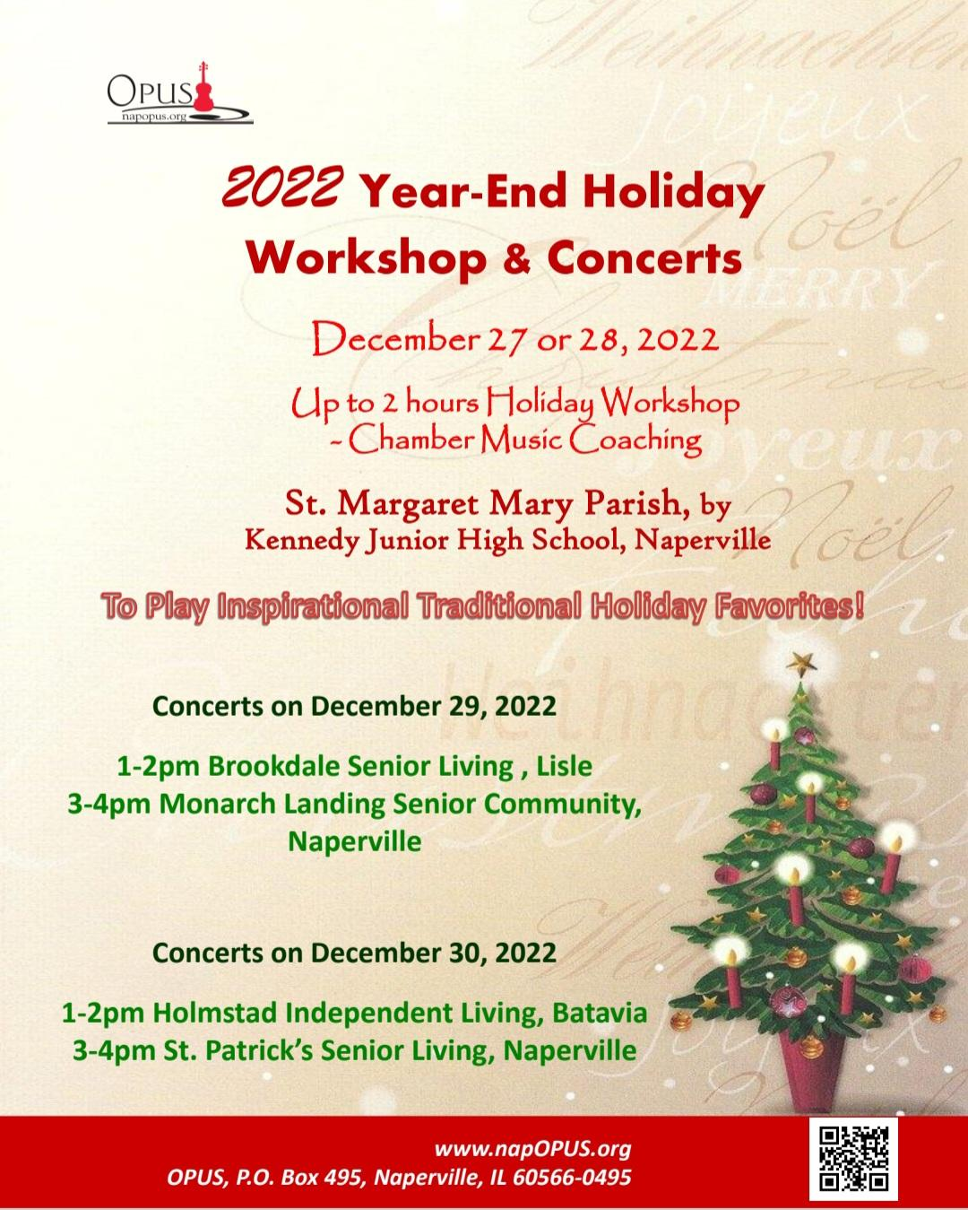
Upcoming Events
OPUS invited SoWE to perform at multiple senior homes on Thursday, December 29 and Friday, December 30.
SoWe was invited by The Chinese Fine Arts Society to perform in the Chicago Philharmonic Orchestra’s panel discussion on Saturday, January 7th at the Chinese American Museum of Chicago. The discussion focuses on Tan Dun’s work, featuring Grammy-award winning classical guitarist Sharon Isbin, cello virtuoso Joshua Roman, pipa virtuoso Yang Wei, and Chicago Philharmonic Artistic Director Scott Speck.
Recent and Upcoming Videos
Jasmine’s solo, 伊利河畔 was uploaded to the SoWE Youtube channel. Great job Jasmine!
Angela’s solo, Speak Softly Love (The Godfather Theme) has also been posted. Thank you Daniel, for the cinematic editing!
Special thanks to Mika’s dad and godfather for documenting our 2023 Walk for Wishes! Here are some videos and pictures of this event.
Feel free to check out these videos and please be on the lookout for upcoming posts!
Notices
Reminder to SoWE volunteers: Please remember to continuously update your logs throughout the year, whenever you have earned hours.

