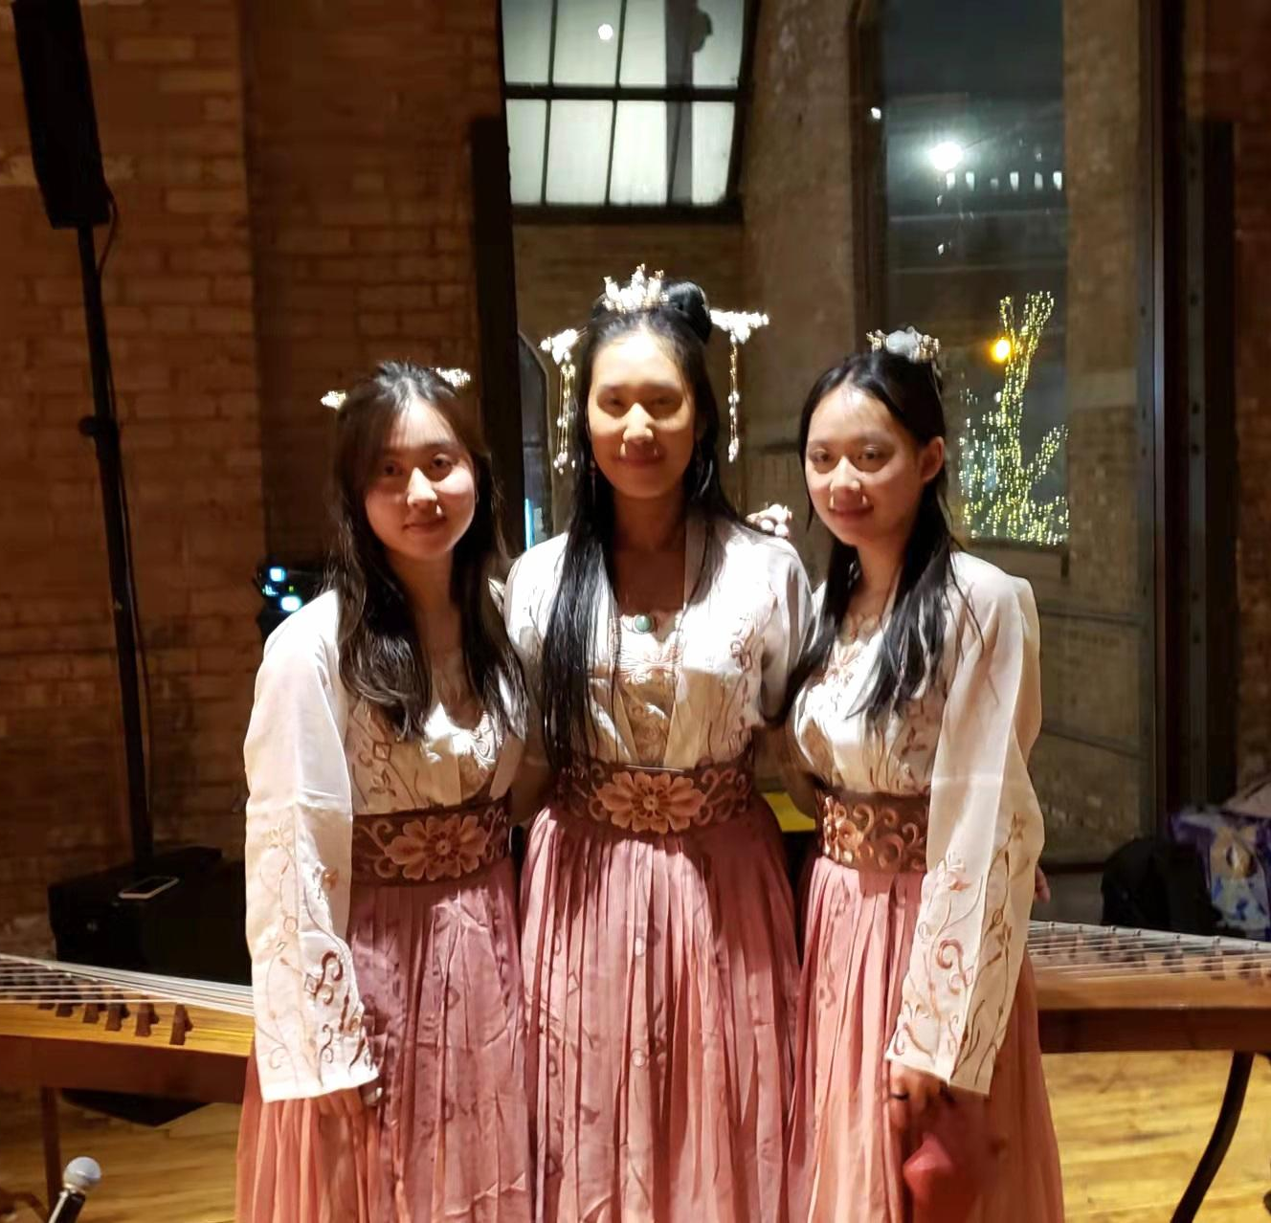
February Recap
Welcome to Sophia and Angela’s new students! On Sunday, February 20th, Emily, Sophia, and Angela attended a wedding as cocktail hour entertainment. In preparation, SoWE alumni Emily, musical performance members Sophia and Angela found and perfected various popular songs. We hope to appeal to more western audiences through these pieces.

Upcoming Events
SoWE’s musical performance team will submit a video for Make-A-Wish Illinois’ 2022 Wish Stars Talent Show by March 31st. The board is currently in the process of designing a new banner to use at SoWE events.
Recent and Upcoming Videos
The video for the December 5th, 2021 Ray Chinese School performance at Pacifica Square was posted.
Sophia plans to record a solo and post it on SoWE’s Youtube channel.
In the meantime, feel free to check out our most recent videos:
Ray Chinese School Performance
2021 Walk for Wishes
"Zulema" Performance at Millennium Park
Current Projects
The board is currently discussing options for our annual project. As of right now, one of the most promising choices is for SoWE to hold its own fundraiser walk (similar to Make-A-Wish’s Wish Walk) where attendees can walk a certain distance to fundraise a set amount. Alternatively, SoWE can also host a show, where entrance fees would be the main source of revenue. If there are any suggestions, please let us know via Wechat or email.
Notices
Reminder to SoWE volunteers: Please continue to track and log your hours. We will reward volunteers with certificates for the number of logged hours throughout the fiscal year at our annual meeting.
The board of directors currently has an opening for its marketing position. If any parents (or ages 18+) are interested, please submit the following form by March 31st. Please remember to select “marketing” on the Google form.

