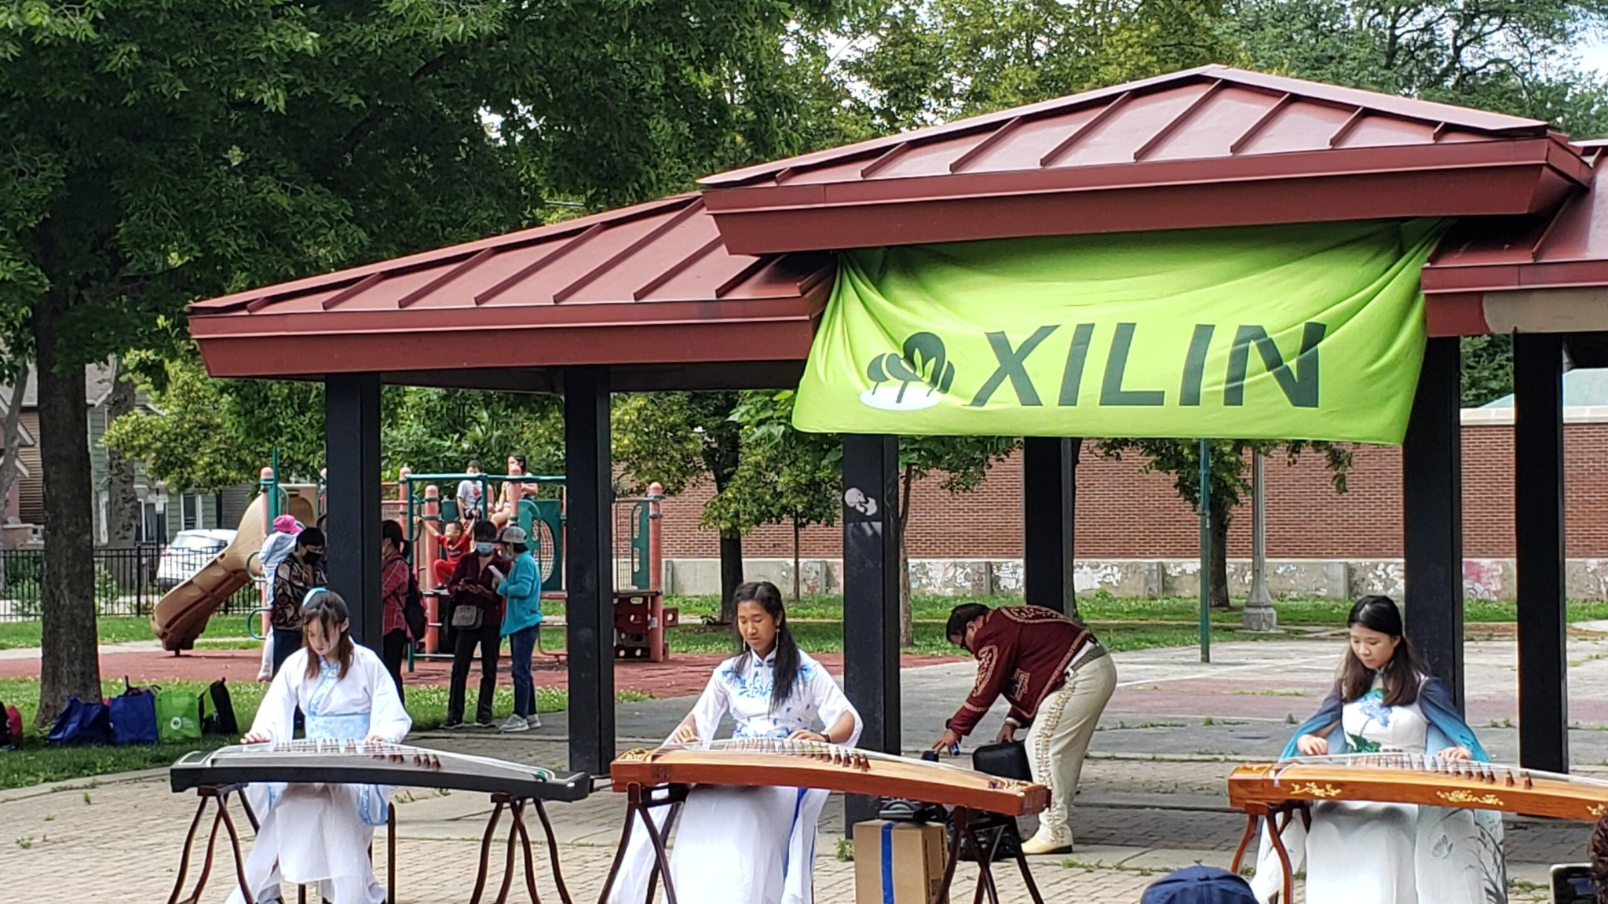
July Recap
On Saturday, July 8, Angela, Jasmine, and Sophie performed at Dvoal Park for an event hosted by the Xilin Association and the 25th Ward Alderman Office.
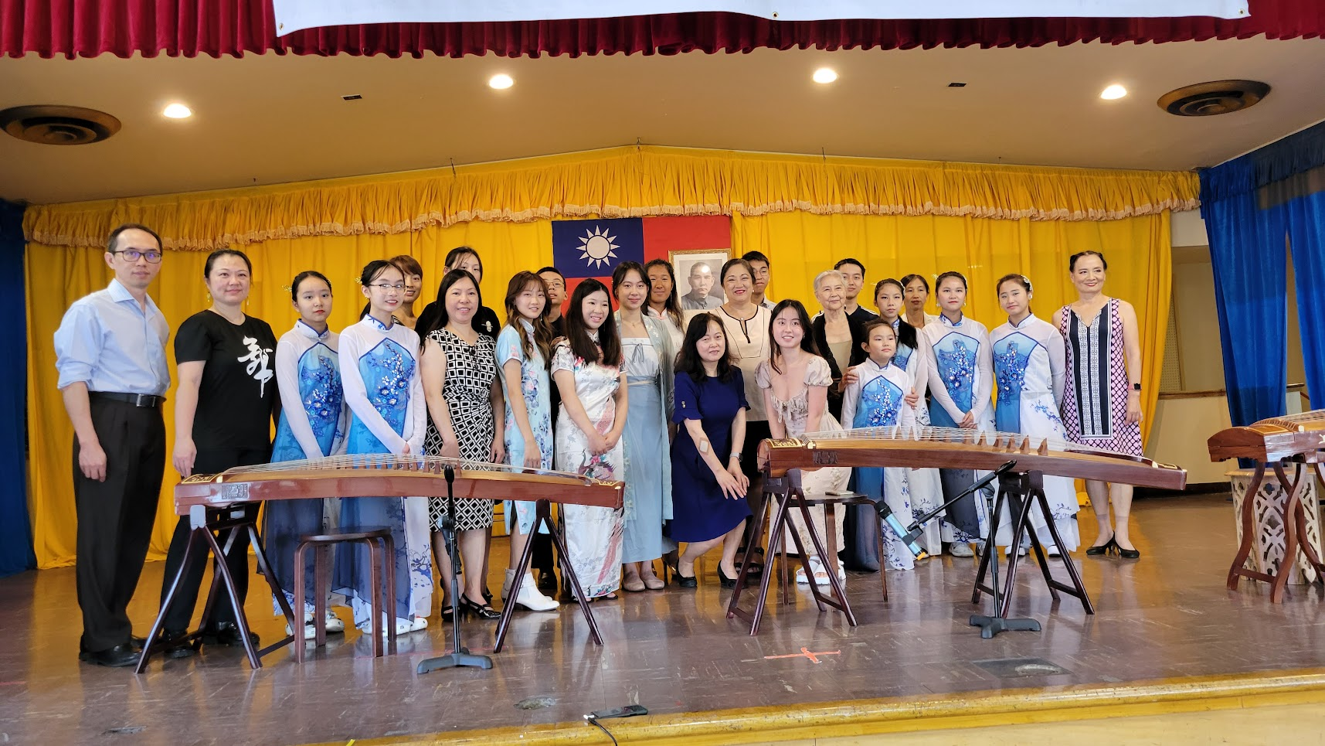
On Thursday, July 13, they played at Navy Pier’s annual Fresh Fest.

August/September Events
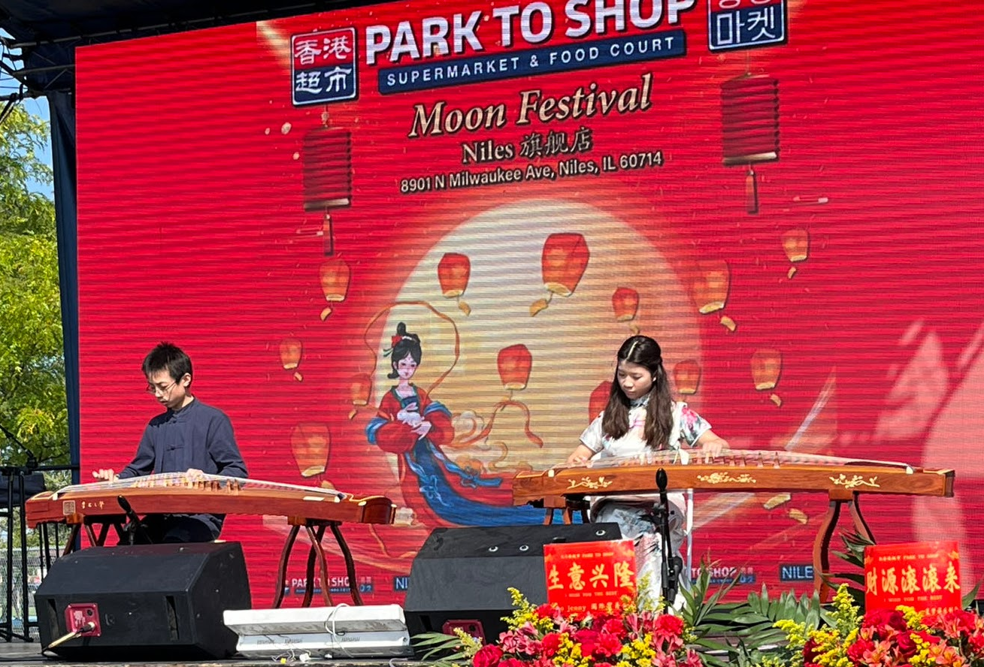
On Sunday, August 19, SoWE held our first fundraising concert at the Chinese Community Center. We sold 164 tickets and raised over $10,000 for Lurie Children’s Hospital's childhood cancer research! Thank you so much for your support!
Jasmine and Andrew performed at the Niles Park to Shop’s grand opening and Mid Autumn Festival celebration on Saturday, September 30. Thank you to Andrew and Jasmine for representing SoWE!
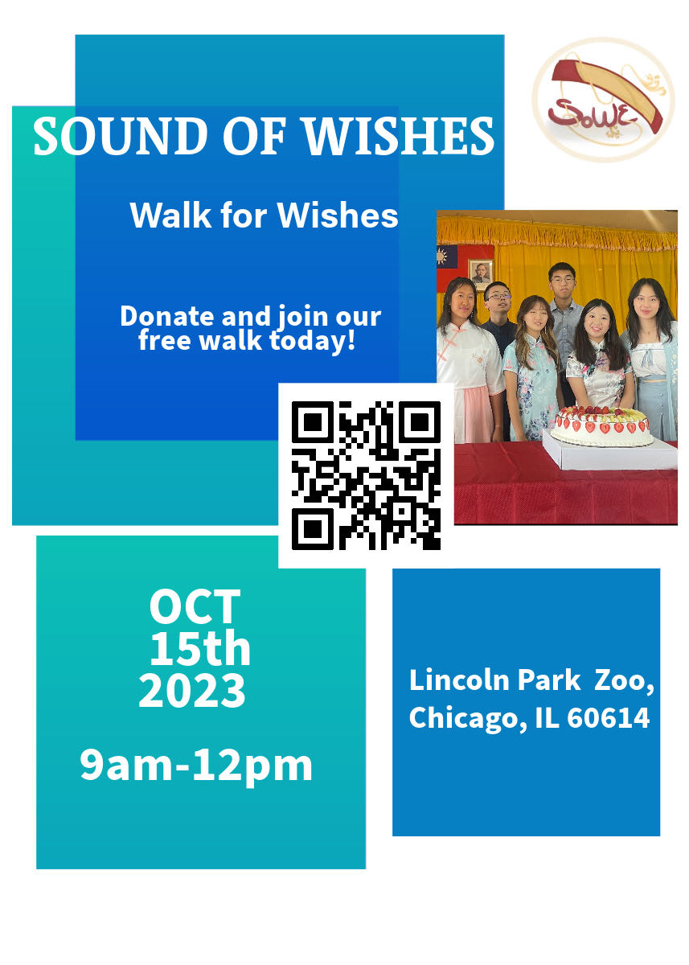
Upcoming Events
On Sunday, October 15, SoWE will participate in the annual Walk For Wishes at Lincoln Park from 9 a.m. - 12 p.m. This year’s team captains are Angela, Arthur, and Jasmine. Please help us reach our fundraising goal of $1,500 and sign up for the free walk. SoWE will 1:1 match donations up to $1,000. We will perform in front of the Lincoln Park Zoo sign and distribute various awards after the walk ends.

Recent and Upcoming Videos
Angela and Mika released their duet, Three Inches Of Heaven, our most recent post. Great job Mika and Angela!
Please stay tuned for upcoming posts!

Notices
Volunteers, please regularly update your service hours log.
Starting this year, we will award the PVSA to volunteers. For those who did not meet the threshold, SoWE will reward volunteers with certificates for their number of hours throughout the fiscal year (5/1-4/30) on October 15, after the Walk for Wishes.
PVSA requirements:
Bronze: 50-74 hours (ages 11-15) 100-174 hours (ages 16-18)
Silver: 75-99 hours (ages 11-15) 175-249 hours (ages 16-18)
Gold: 100+ (ages 11-15) 250+ hours (ages 16-18)

Congratulations to this year’s PVSA recipients!
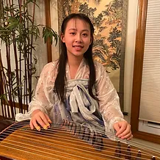
Sophia Angela Jasmine
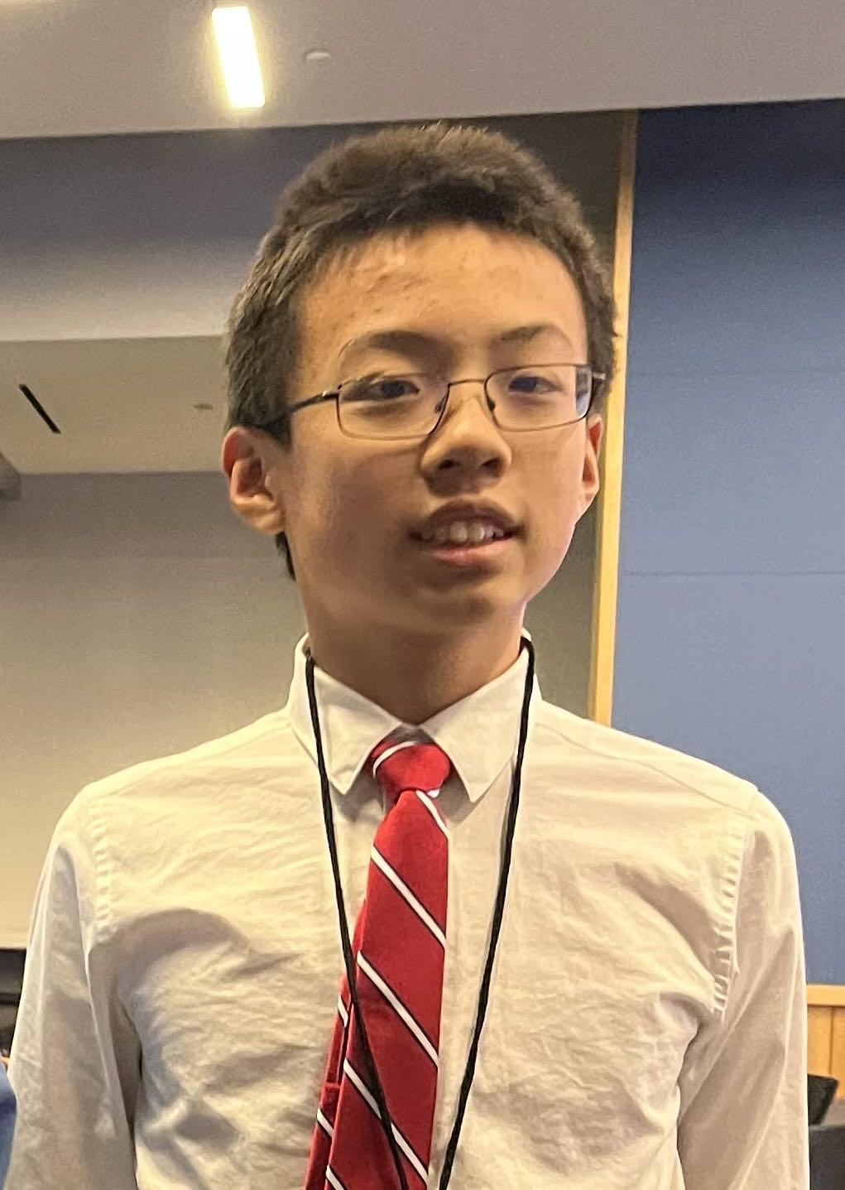
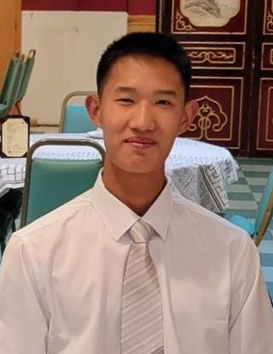
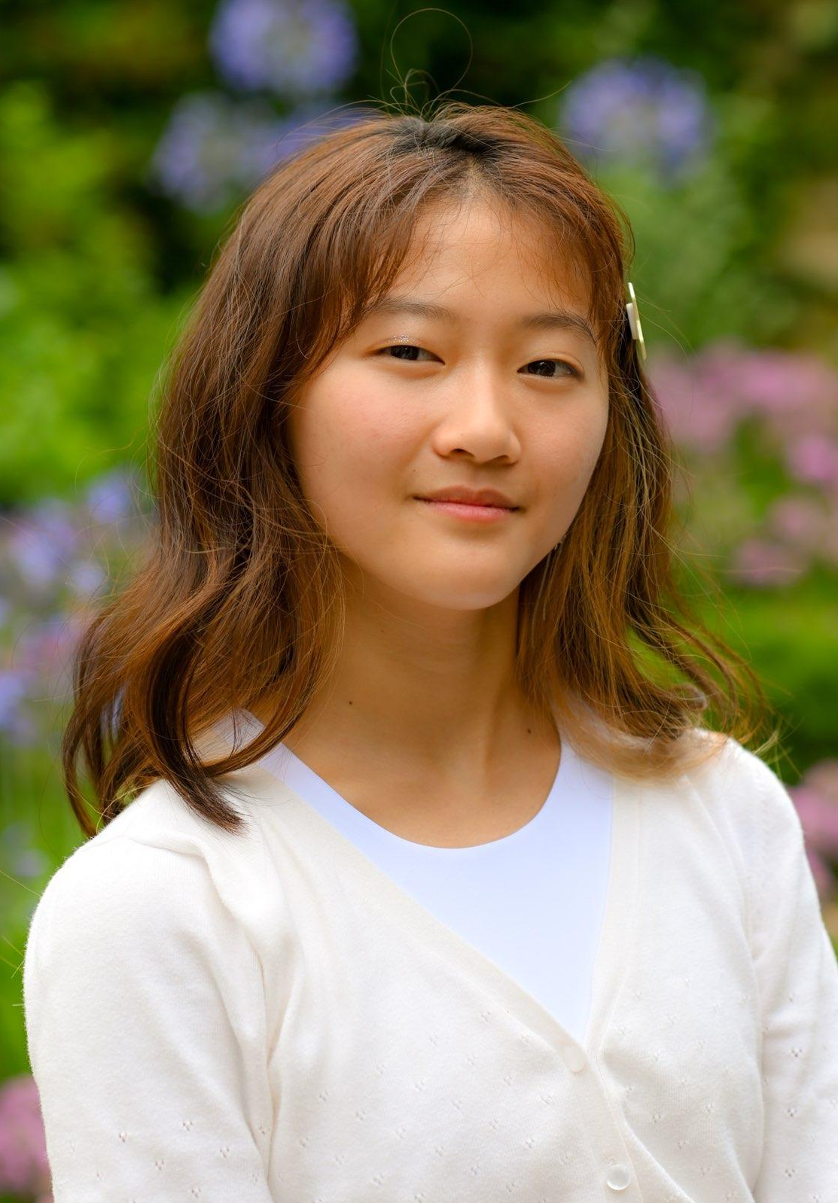
Mika Daniel Andrew

