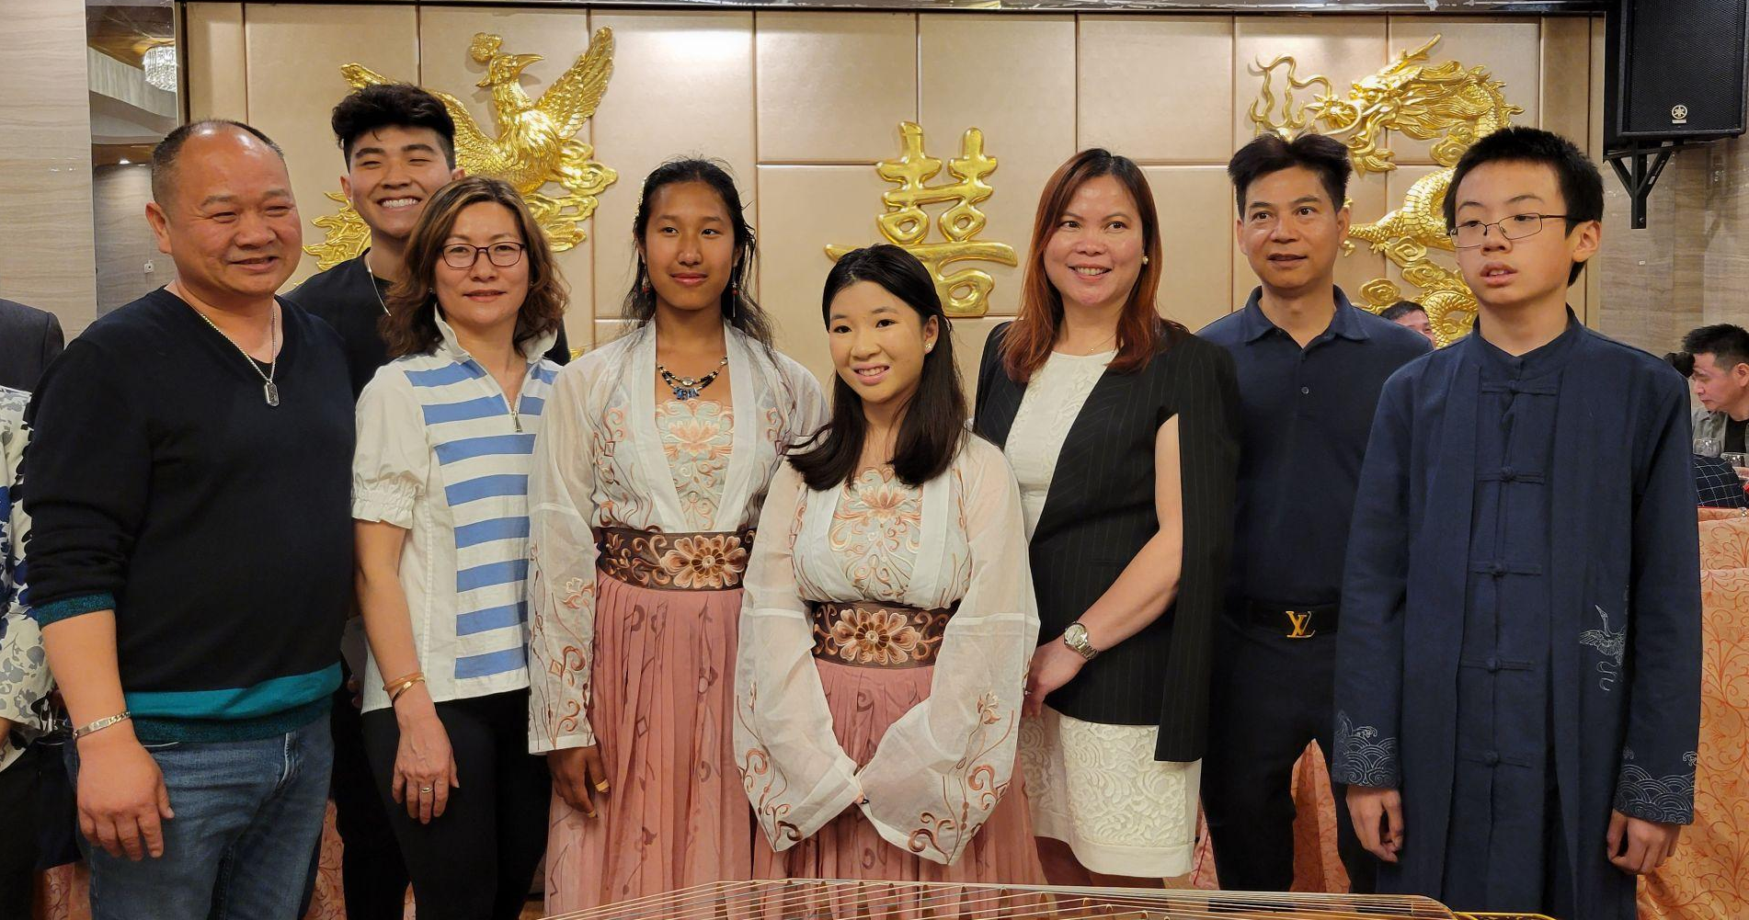
May Recap
On Tuesday, May 16, Angela, Jasmine, and Andrew performed at an event hosted by the Hong Kong Club at Chinatown’s Phoenix restaurant.

June Events
SoWE did not have events during June. However, we will have multiple performances in July. Please be on the lookout!
This year, SoWE will host an annual concert instead of a meeting. Please spread the word! Tickets cost $20 each. The funds will be donated to Lurie Children’s Hospital. Time spent selling tickets will count as volunteer hours (further detail in the “Notices” section).
Recent and Upcoming Videos
Max posted his solo, a violin cover of Meditation from Thais. Andrew released his first solo, 山丹丹开花红艳艳. Great job Max and Andrew! Please support their videos!
In addition, SoWE posted 不染 (Bu Ran). This is the first complete ensemble video in a couple of months.
Feel free to check out these uploads and please stay tuned for upcoming posts!
Notices
Each concert ticket sold is worth 30 minutes of volunteer service. Additionally, time spent handing out flyers and trying to sell tickets also counts as service (with parental confirmation).
Starting this year, we will award the PVSA to volunteers. For those who did not meet the threshold, SoWE will reward volunteers with certificates for their number of hours throughout the fiscal year (5/1-4/30).
PVSA requirements:
Bronze: 50-74 hours (ages 11-15) 100-174 hours (ages 16-18)
Silver: 75-99 hours (ages 11-15) 175-249 hours (ages 16-18)
Gold: 100+ (ages 11-15) 250+ hours (ages 16-18)

