June Recap
SoWE did not have any events in June. However, we had multiple performances in July!

July Events
On Saturday, July 8, Angela, Jasmine, and Sophie performed at an event hosted by Xilin Association and 25th Ward Alderman Office at Dvoal Park. On Thursday, July 13, they participated in the Fresh Fest Event at NavyPier.
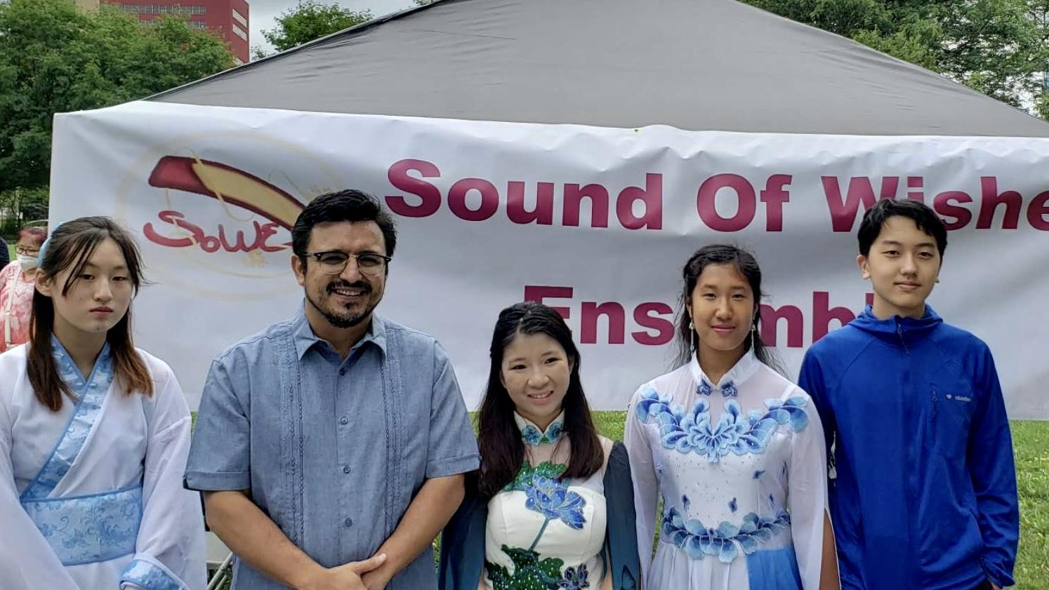
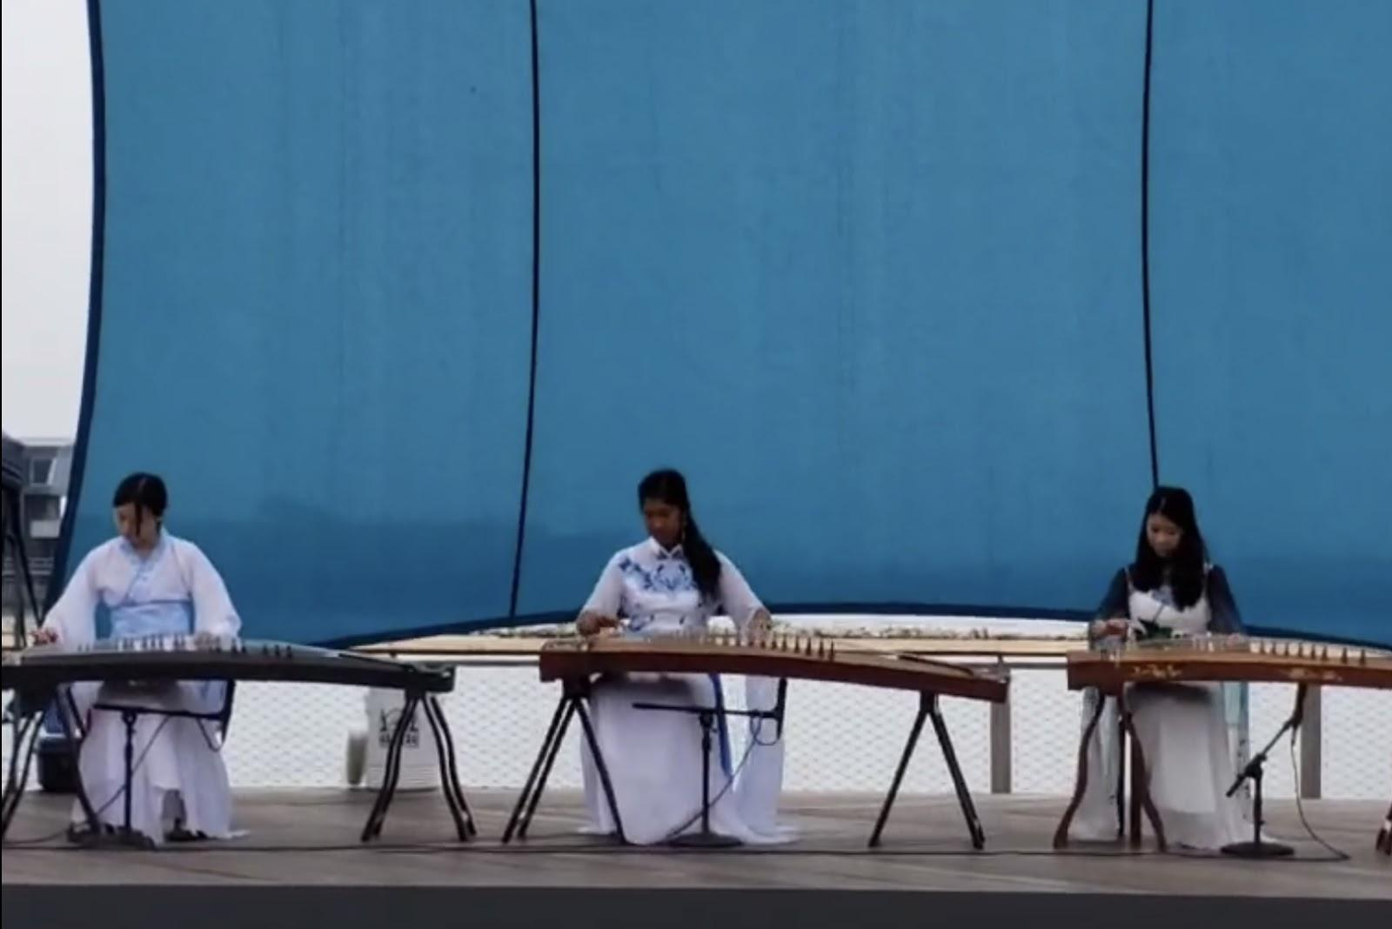
Recent and Upcoming Videos
Angela and Mika’s posted their duet playing Three Inches of Heaven" (三寸天堂). Great job Angela and Mika! Please stay tuned for the upcoming videos!

Current Projects
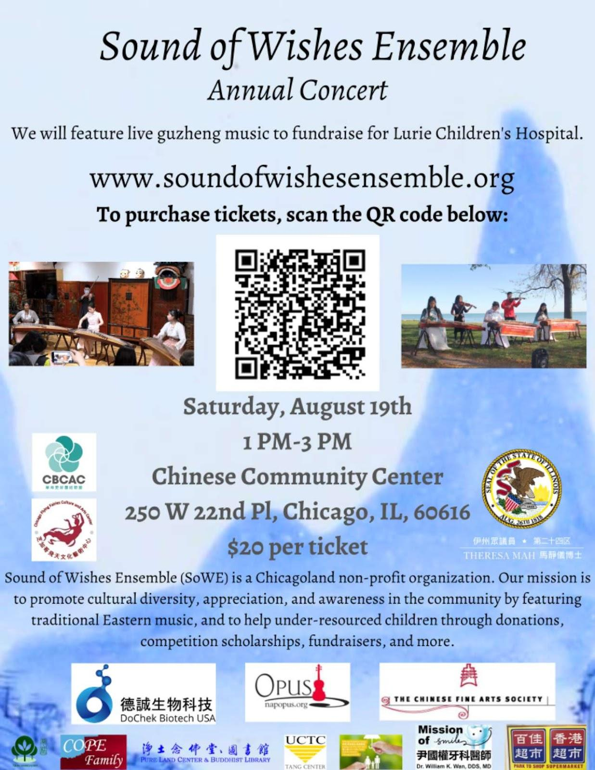
This year, SoWE will host a fundraising concert on August 19 at the Chinese Community Center. Tickets cost $20 each. The funds will be donated to Lurie Children’s Hospital for Children Cancer Research.
Notices
Please spread the word for our fundraising concert! Each concert ticket sold is worth 30 minutes of volunteer service. Additionally, time spent handing out flyers and trying to sell tickets also counts as service (with parental confirmation).

Below are the volunteer roles:
1) Reception desk collecting tickets + coordinate the raffle gifts
2) Meeting/guiding the audience to their seats + arrange venue /make sure chairs setting + set up SoWE banner
3) Persons setting up the music equipment + testing it a day before + background music
4) A person ordering the food and set up table for Sowe performers and members
5) Filming/ recording
6) Photographing

Student volunteers will get volunteer hours. Parents are welcomed to volunteer. The deadline to register is 8/5. If you are interested please directly message Jasmine on we chat.

