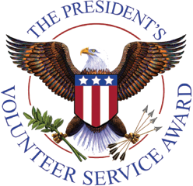
March Recap
SoWE has become a certified organization for the President’s Volunteer Service Award (PVSA). Thank you to Stella and Heidi for completing this process!
Board member/department director elections have ended. Congratulations to our new leaders!
Vice Presidents: Angela Wang and Jasmine Fong
Director of Film Production: Arthur Cai
Director of IT and Communications: Mika Chang

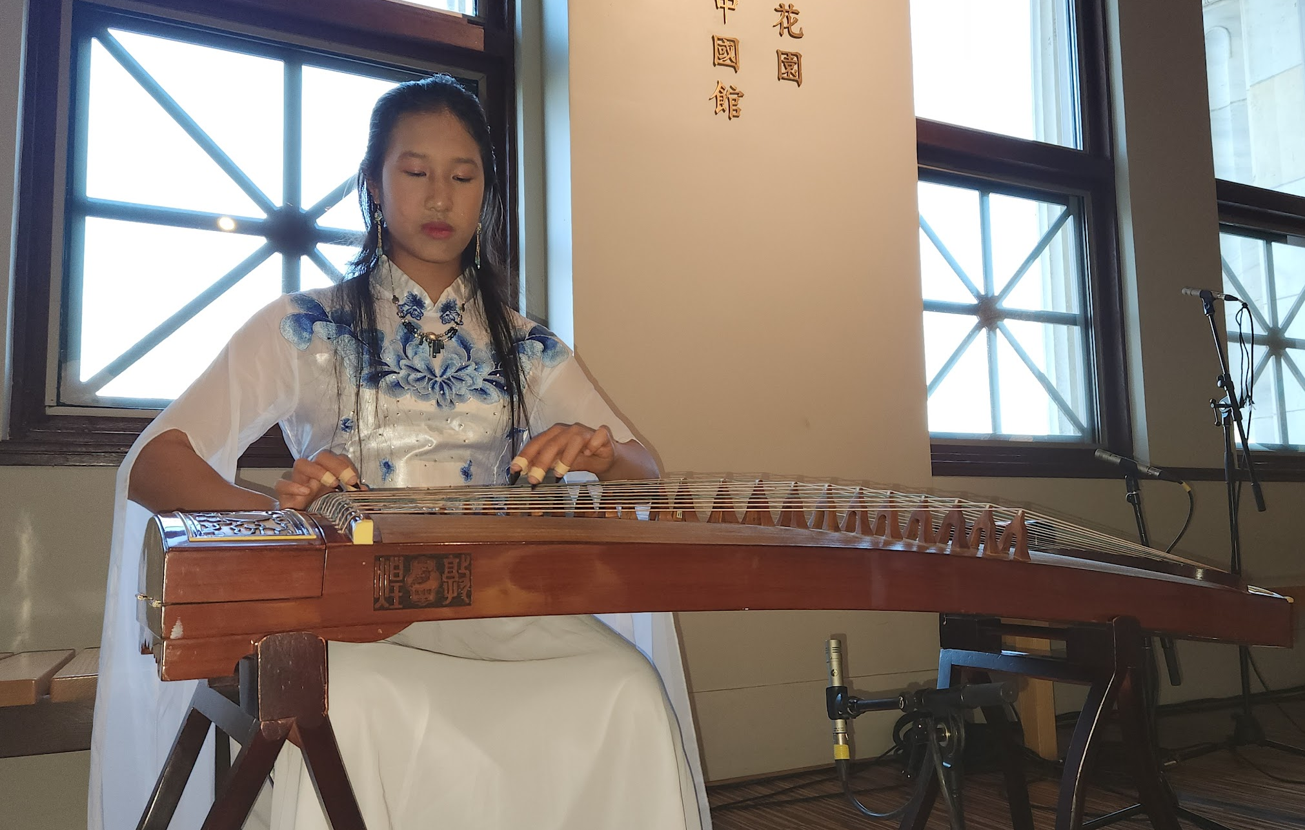
Upcoming Events
On Thursday, April 13, Angela performed with Yin He dance at the Field Museum.
On Sunday, April 30, Angela and Jasmine will perform in CPS’s Reverberate in the Museum of Contemporary Photography on behalf of SoWE. Angela’s solo, 彝族舞曲, will be performed at 1:00 pm. Jasmine and Angela’s duet, 雪山春晓, is scheduled to start at 1:15 pm.
Recent and Upcoming Videos
Angela’s student, Maylin, uploaded her first solo, 渔舟唱晚 (Fisherman’s Song at Dusk) to the SoWE Youtube channel. Andrew, Sophia’s student, recently posted his first solo, 山丹丹开花红艳艳.
Congratulations to both Maylin and Andrew! Please support their videos!
The recording for SoWE’s Chicago Philharmonic Performance at the Chinese American Museum of Chicago is out. Thank you Henry and Daniel, for such an excellent video!
SoWE released 不染 (Bu Ran) several days ago. This is the first full ensemble in a couple of months.
Feel free to check out these videos and please be on the lookout for upcoming posts!
Notices
Reminder to SoWE volunteers: Please finalize your volunteer hour logs by Sunday, May 7th. Transferred hours will be accepted until May 14. However, volunteers must present proof (e.g. a certificate or signed letter) of their community service.
Starting this year, we will award the PVSA to volunteers. For those who do not meet the threshold, SoWE will reward volunteers with certificates for their number of hours throughout the fiscal year.
PVSA requirements:
Bronze: 50-74 hours (ages 11-15) 100-174 hours (ages 16-18)
Silver: 75-99 hours (ages 11-15) 175-249 hours (ages 16-18)
Gold: 100+ (ages 11-15) 250+ hours (ages 16-18)

