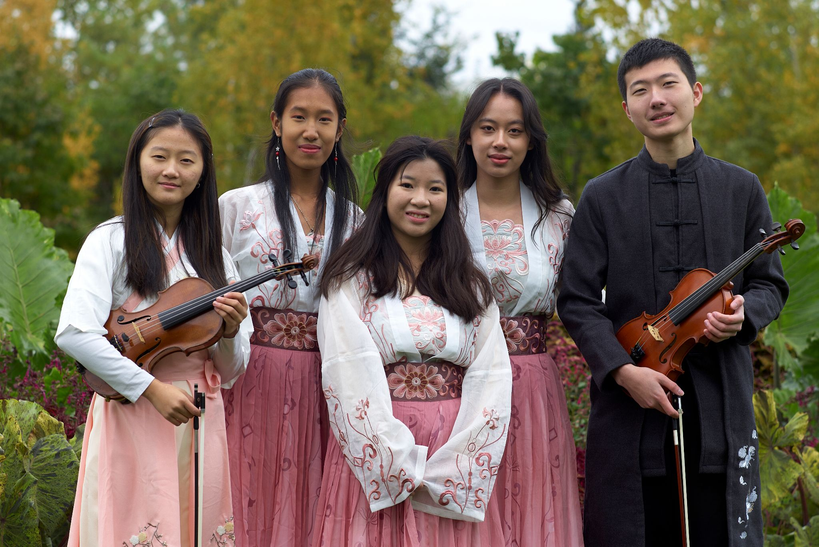
Recap
On Friday, July 15, Sophia, Max, and Jasmine represented SoWE, performing at Navy Pier’s 2022 Fresh Fest.
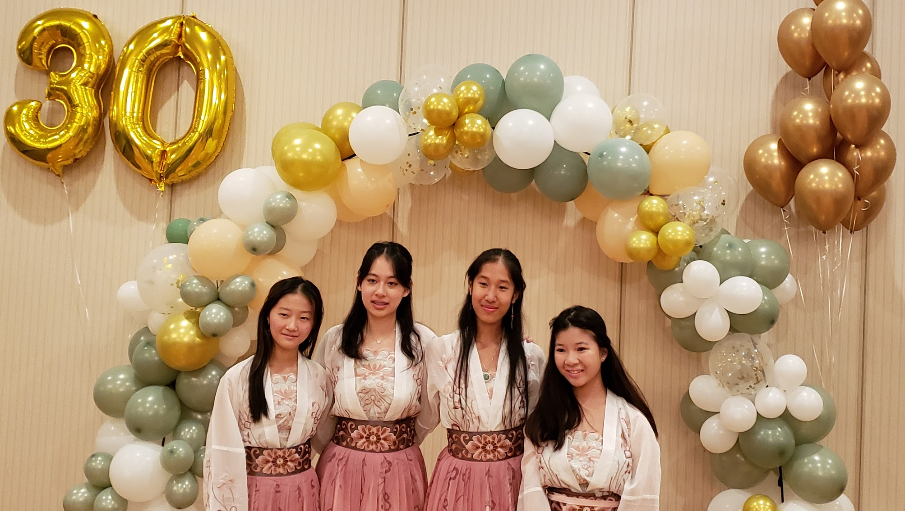
Thank you to all those who made this year’s July 23rd annual meeting a success! Special thanks to the Chinese Community Center for renting us their wonderful venue and to Daniel and Angela for their amazing job organizing and hosting our 2022 annual concert. Congratulations to all our performers and award recipients! It was incredible seeing everyone!
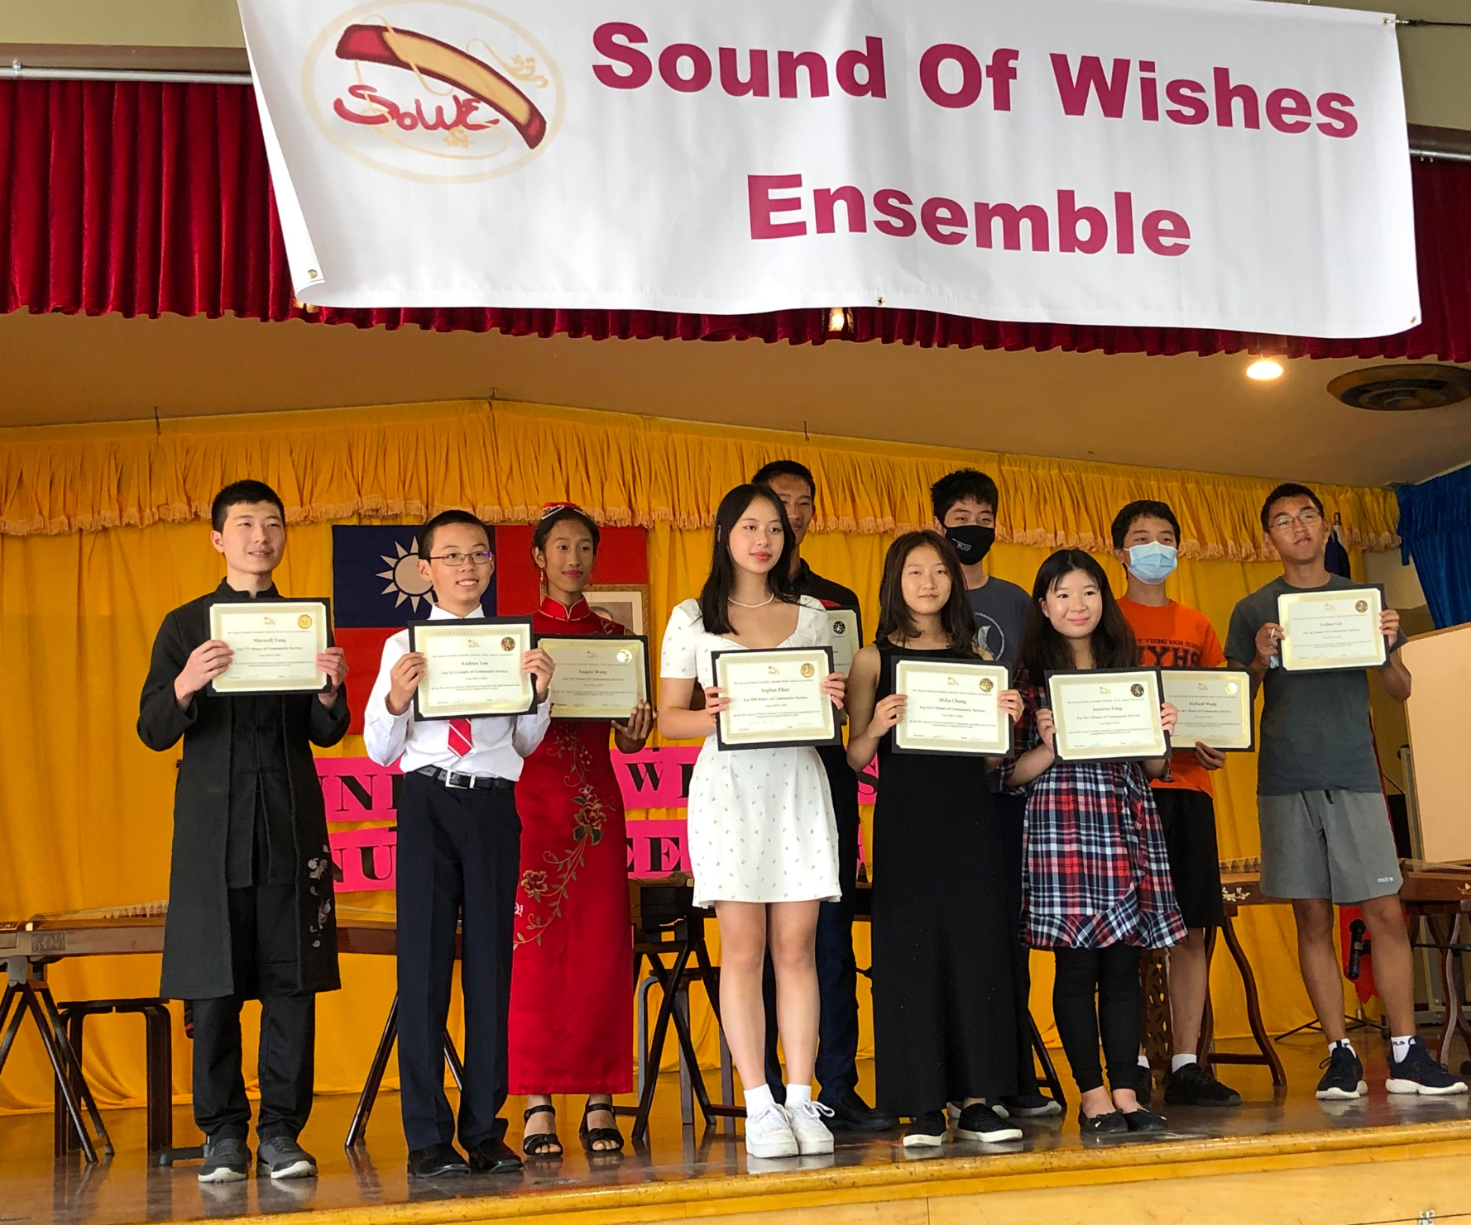
On Sunday, October 16, SoWE participated in the annual Walk for Wishes at Lincoln Park Zoo. Sophia and Mika did a terrific job organizing this year’s event! Thank you to everyone’s continuous donation and support, allowing SoWE to exceed our goal, raising a total of $2,642! We really appreciate all those who attended the walk, including our musical performance team on such a cold Sunday morning.
SoWE performed at Ray Chinese School’s 30th anniversary celebration on Friday, October 21.

Upcoming Events
Walk for Wishes and Ray Chinese School’s anniversary celebration were our main October events. Stay tuned for November!
Recent and Upcoming Videos
Mika’s solo, Ghost was uploaded to the SoWE Youtube channel. Great job Mika!
Angela’s solo, Speak Softly Love (The Godfather Theme) has also been posted. Thank you Daniel, for the cinematic editing!
Highlights of SoWE’s 2022 Annual Concert are out. Thank you Arthur, for such an excellent recap!
Special thanks to Mika’s dad and godfather for documenting our 2023 Walk for Wishes! Here are some videos and pictures of this event.
Feel free to check out these videos and please be on the lookout for upcoming posts!
Notices
Reminder to SoWE volunteers: Please remember to continuously update your logs throughout the year, whenever you have earned hours.

