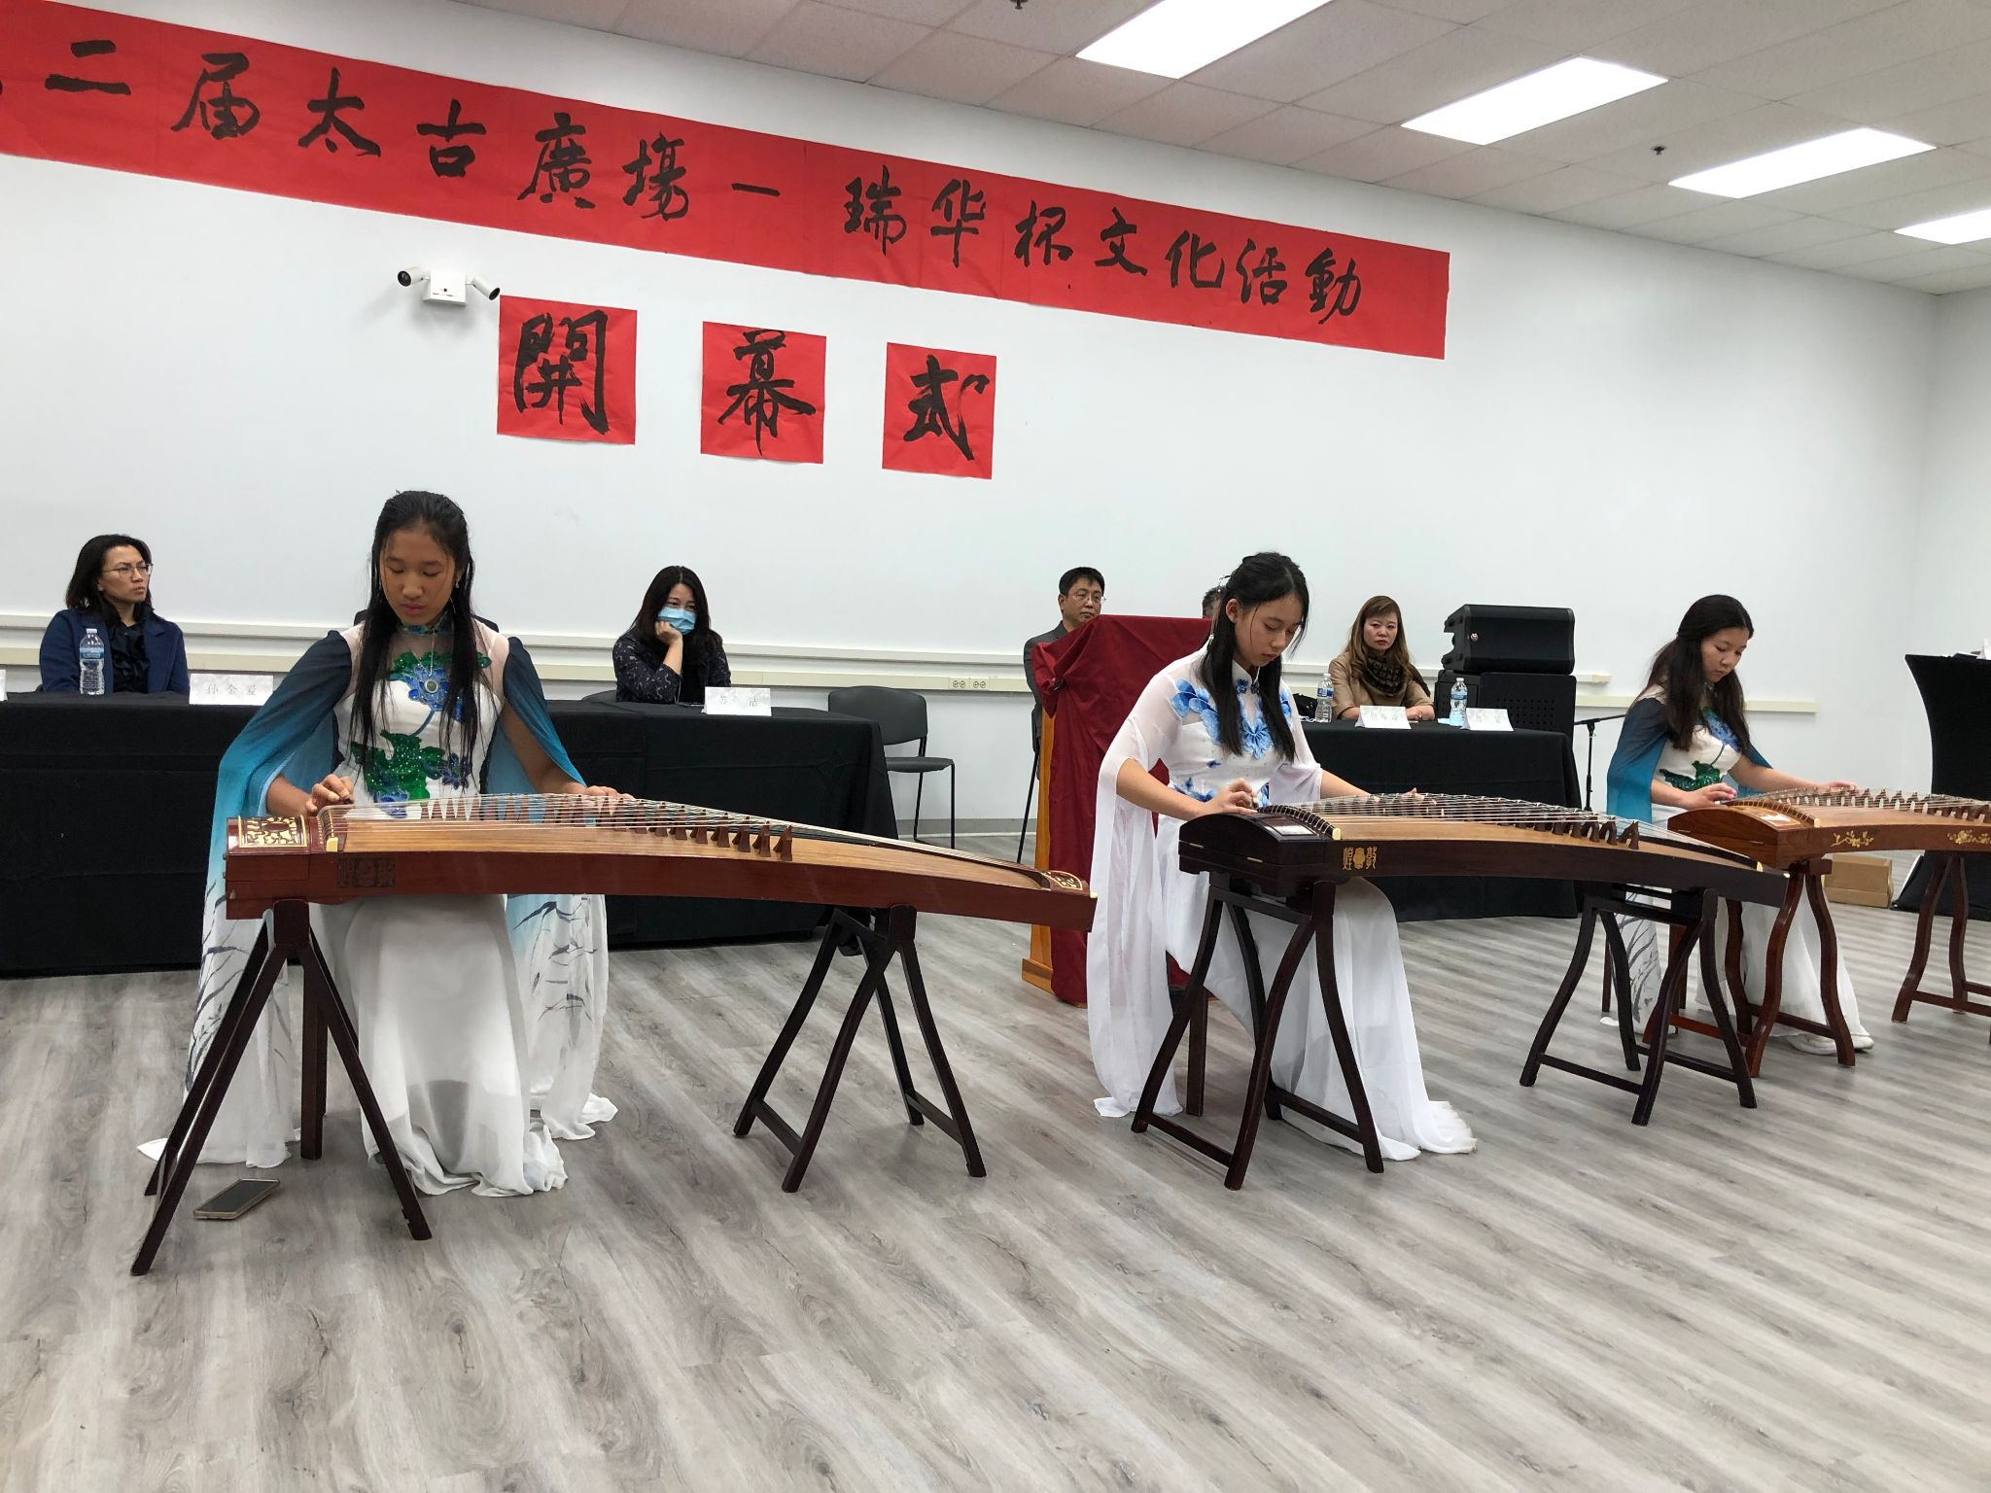
December Recap
Welcome to Henry, our newest member!
On December 5th, 2021, Sound of Wishes (SoWE) performed at Pacifica Square to support Ray Chinese School’s PVSA Award Ceremony.
SoWE represented the United Chinese Americans (UCA) Chicago chapter at the UCA Holiday Party. The ensemble’s cover on 万水千山总是情 (Love and Passion) was selected for the virtual performance.

Recent and Upcoming Videos
Sophia plans to record a solo and post it on SoWE’s Youtube channel.
In the meantime, feel free to check out our most recent videos:
2021 Walk for Wishes
"Zulema" Performance at Millennium Park
SoWE Performances at Navy Pier and Chinatown
叹云兮 TanYunXi Guzheng Cover
Current Projects
The board is currently discussing options for our annual project. In the past two years, our projects have been focused on fundraising for Feeding America in response to COVID and, a year later, spreading the beauty of Asian culture (Peace and Harmony). If there are any suggestions, please let us know via Wechat or email.
Notices
For members who have not already, please submit a picture and short biography to Max. Additionally, please fill out the Contact Information Form.

