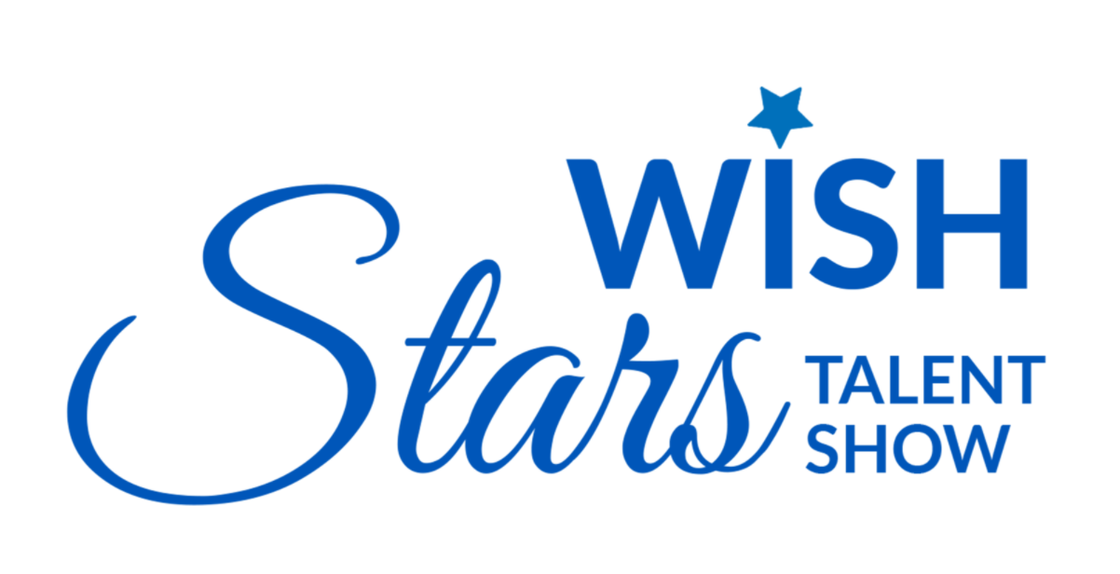
March Recap
SoWE’s musical performance submitted a video for Make-A-Wish Illinois’ 2022 talent show.

Upcoming Events
Congratulations to Stella, Jasmine’s mom for being selected as SoWE’s new marketing officer! SoWE was chosen for Make-A-Wish Illinois’ 2022 Wish Stars Talent Show. Please support us by donating, voting, and sharing our fundraising link. SoWE will (1:1) match all donations made up to a total of $1000. The matched amount will be added at the end of the fundraiser.
Recent and Upcoming Videos
Sophia plans to post a solo on Sunday, April 17.
Angela plans to release a solo on Sunday, May 1, two weeks after Sophia’s video.
In the meantime, feel free to check out our most recent videos:
Ray Chinese School Performance
2021 Walk for Wishes
"Zulema" Performance at Millennium Park
Current Projects
The board is currently discussing options for our annual project. As of right now, one of the most promising choices is for SoWE to hold its own fundraiser walk (similar to Make-A-Wish’s Wish Walk) where attendees can walk a certain distance to fundraise a set amount. Alternatively, SoWE can also host a show, where entrance fees would be the main source of revenue. If there are any suggestions, please let us know via Wechat or email.
Notices
Reminder to SoWE volunteers: Please continue to track and log your hours. We will reward volunteers with certificates for the number of logged hours throughout the fiscal year at our annual meeting.
This year, our annual meeting will take place during the month of July. Further details are to be determined.

